Simple text in Times New Roman 12 followed by an empty paragraph_{subscript} and^{superscript}.

Various characters: ‘ “ & < > £ ¥ § ¨ © ª « ® » ¼

Paragraph with multiple segments of text formatted in different fonts, sizes and colors. Very different sizes and colors including bold, italic, underline and 1 2 3 4 5 strikethrough.

This text has shading and highlighting and borders.

Paragraph Formatting
Right aligned paragraph.
Center aligned paragraph.
Center aligned paragraph.
Right aligned paragraph.
This paragraph is a test for double line spacing. This paragraph is a test for double line spacing. It also has 0.5” for the first line.
This is a test for Exactly 20 points of spacing. This is a test for Exactly 20 points of spacing. TTTTTT (20, 22, 24, 26, 28, 30).

Paragraph Justify
This is a justified paragraph with a single segment. 111111111111111111111111111111111111111111.
Also a justified paragraph reset to left because of multiple segments. 111111111111111111111111111111111111111111.

Tables
Cell 1.1 Left |  | Cell 1.2 Right
Cell 2.1 Centered vertically | Cell 2.2 with background |  | Cell 2.3 with line break  and colored border.
Cell 3.1 Bottom vertically | Cell 3.2  Centered  Horizontally |  | Cell 3.3 No border

Left red, blue top, green right and yellow bottom.

Cell padding different and all sides.
Cell padding.  Top: 0.1, bottom 0.2  Left: 0.5, Right 0.4 | Zero padding on all sides, right aligned.

Outer 1.1 | Outer 1.2. There is a nested table here | Outer 1.3
  Nested 1.1 | Nested 1.2

Lists
Numbered list:
- Item 1
- Item 2
  - Item 2.1
  - Item 2.2
- Item 3
Bulleted list:
- Item 1
- Item 2
  - Item 2.1
  - Item 2.2
- Item 3

Images
This section starts from a new page.

There is inline JPEG in a separate paragraph.
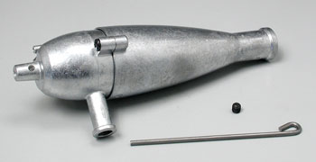

Inline GIF scaled 50% and WMF scaled 25% in a paragraph. This text is before the image and 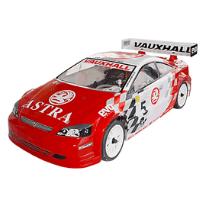 this text is after the image.

There are images in a table. Left and right aligned.
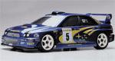 | 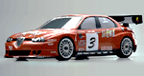

Inline text box is here and inline ellipse is here.
Textbox text.

TOC and Footnotes
Hyperlink Aspose.com
TOC
Paragraph Formatting 1
Paragraph Justify 1
Tables 1
Lists 3
Images 4
TOC and Footnotes 5

This line has a footnote at the end.
This line has an endnote at the end.

Footnote 1.
Endnote 1.

